Assessment Brief

|  |  |
| --- | --- |
| Student Name/ID Number |  |
| **Unit Number and Title** | **14: Business Intelligence** |
| Academic Year | 2018 |
| Unit Tutor |  |
| **Assignment Title** | **Assignment 2: Apply BI tools & techniques and their impact** |
| **Issue Date** |  |
| Submission Date |  |
| IV Name & Date |  |

|  |
| --- |
| **Submission Format** |
| Part I: Project submission. This should be a zip / rar folder of your project, including all necessary files to run your project. There should be a link to your Tableau work on Tableau Public cloud.  Part II: The submission is in the form of a group written report. This should be written in a concise, formal business style using single spacing and font size 12. You are required to make use of headings, paragraphs and subsections as appropriate, and all work must be supported with research and referenced using the Harvard referencing system. Please also provide a bibliography using the Harvard referencing system.  Part III: Team needs to present their point of view about how business intelligence tools can contribute to effective decision-making as well as the legal issues involved in exploiting user data for business intelligence. You may need to research for specific examples of organizations that use BI tools to enhance or improve their business and evaluate how they can use BI tools for extend their target audience and make them more competitive within the market. |

|  |
| --- |
| **Unit Learning Outcomes** |
| **LO3** Demonstrate the use of business intelligence tools and technologies |
| **Assignment Brief** |
| (Continued from previous scenario)  Your next task is to demonstrate to the board of directors about the ability of applying business intelligence in the company's current business processes. To demonstrate BI, you need to prepare a presentation about BI and related tools & techniques and a demonstration on real company dataset.  For the presentation, you need:   * Explain general concept of what is BI * Introduction to some tools / techniques for BI and their application in general   For the demonstration, you need:   * A (some) data set(s) extracted from the company's business processes. Explain the dataset. * Show how you pre-process data for later analysis, explain each step and it purpose * Design dashboards to show your analysis on pre-processed data. Explain clearly purpose of dashboards and charts. Suggestions should be made after analysis   During the demonstration, you need collect feed-back and comments from users to review how well your dashboards design meet user or business requirement and what customization needed for future use.  Team needs to present their point of view about how business intelligence tools can contribute to effective decision-making as well as the legal issues involved in exploiting user data for business intelligence. You may need to research for specific examples of organizations that use BI tools to enhance or improve their business and evaluate how they can use BI tools for extend their target audience and make them more competitive within the market.  To summary, you need to submit a report in PDF includes 4 parts: your presentation, result of demonstration and review of user feedback, point of view on BI contribution and legal issues. |

|  |  |  |
| --- | --- | --- |
| Learning Outcomes and Assessment Criteria | | |
| Pass | Merit | Distinction |
| LO3 Demonstrate the use of business intelligence tools and technologies | | D3 Provide a critical review of the design in terms of how it meets a specific user or business requirement and identify what customisation has been integrated into the design. |
| P3 Determine, with examples, what business intelligence is and the tools and techniques associated with it.  P4 Design a business intelligence tool, application or interface that can perform a specific task to support problem-solving or decision-making at an advanced level. | M3 Customise the design to ensure that it is user friendly and has a functional interface. |
| LO4 Discuss the impact of business intelligence tools and technologies for effective decision-making purposes and the legal/regulatory context in which they are used | | D4 Evaluate how organisations could use business intelligence to extend their target audience and make them more competitive within the market, taking security legislation into consideration |
| P5 Discuss how business intelligence tools can contribute to effective decision-making.  P6 Explore the legal issues involved in the secure exploitation of business intelligence tools | M4 Conduct research to identify specific examples of organisations that have used business intelligence tools to enhance or improve operations. |

Table of Contents

Table of Figures 2

P3 Determine, with examples, what business intelligence is and the tools and techniques associated with it. 3

1.1. General about BI 3

1.1.1. Definition about BI 3

1.1.2. Examples about how BI works on business 4

1.2. BI techniques 5

1.3. BI tools 6

P4 Design a business intelligence tool, application or interface that can perform a specific task to support problem-solving or decision-making at an advanced level. 8

**1.1.** **Dataset(s)** 8

**1.2.** **Pre-process steps on dataset(s)** 9

**1.3.** **Dashboard (Purpose of dashboard)** 16

**1.4.** **Each dashboard contain charts (Purpose of chart)** 18

**1.5.** **Interaction on dashboards (Result / Conclusion / Suggestion)** 20

P5 Discuss how business intelligence tools can contribute to effective decision-making. 21

**1.** **The important of BI to the business** 21

P6 Explore the legal issues involved in the secure exploitation of business intelligence tools 23

**1.** **Data kind which is collected** 23

**2.** **How data stored** 23

**3.** **How Big Data used** 24

REFERENCES 26

Table of Figures

Figure 1 BI on business 5

Figure 2 Dataset (csv file) 10

Figure 3 First UI of Tableau 11

Figure 4 Main UI of Tableau 11

Figure 5 Choosing import file way 12

Figure 6 Dataset after import 13

Figure 7 Table of Price of house 13

Figure 8 Column of Price and Date 14

Figure 9 Dual lines graph of Bedrooms and Bathrooms built 15

Figure 10 Maps of Zipcode and Bathrooms sold 16

Figure 11 Compare Column and Table graph 18

Figure 12 Dashboard 19

**ASSIGNMENT 2’S ANSWER**

# P3 Determine, with examples, what business intelligence is and the tools and techniques associated with it.

## General about BI

### Definition about BI

Business intelligence (BI) refers to the procedural and technical infrastructure that collects, stores, and analysis the data produced by a company’s activities.

BI is a broad term that encompasses data mining, process analysis, performance benchmarking, and descriptive analytics. BI parses all the data generated by a business and presents easy-to-digest reports, performance measures, and trends that inform management decisions.

* BI represents the technical infrastructure that collects, stores, and analyses company data.
* BI parses data and produces reports and information that help managers to make better decisions.
* Software companies produce BI solutions for companies that wish to make better use of their data.
* BI tools and software come in a wide variety of forms such as spread sheets, reporting/query software, data visualization software, data mining tools, and online analytical processing (OLAP).
* Self-service BI is an approach to analytics that allows individuals without a technical background to access and explore data.

The need for BI was derived from the concept that managers with inaccurate or incomplete information will tend, on average, to make worse decisions than if they had better information. Creators of financial models recognize this as “garbage in, garbage out.”

BI attempts to solve this problem by analysing current data that is ideally presented on a dashboard of quick metrics designed to support better decisions.

### Examples about how BI works on business

There are many reasons why companies adopt BI. Many use it to support functions as diverse as hiring, compliance, production, and marketing. BI is a core business value; it is difficult to find a business area that does not benefit from better information to work with.

Some of the many benefits companies can experience after adopting BI into their business models include faster, more accurate reporting and analysis, improved data quality, better employee satisfaction, reduced costs, and increased revenues, and the ability to make better business decisions.

* Big Data is a collection of large, dynamic data sets containing both structured and unstructured data that can be challenging to analyze and interpret using traditional database administration techniques.
* A data warehouse is an automated, subject-oriented architecture for reporting and reviewing data to enhance decision-making.
* Data mining is the process of transforming large amounts of raw data into useable information with new patterns and relationships in relational databases using computer approaches.

The diagrammatic illustration of the BI implementation technique shown below can help you understand Business Intelligence better

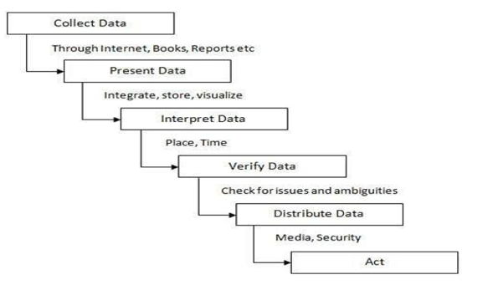

Figure 1 BI on business

## BI techniques

| **TECHNIQUE** | **DESCRIPTION** |
| --- | --- |
| **Data mining** | Sorting through large datasets using databases, statistics, and machine learning to identify trends and establish relationships |
| **Querying** | A request for specific data or information from a database |
| **Data preparation** | The process of combining and structuring data in order to prepare it for analysis |
| **Reporting** | Sharing operating and financial data analysis with decision-makers so they can draw conclusions and make decisions |
| **Benchmarking** | Comparing current business processes and performance metrics to historical data to track performance against industry bests |
| **Descriptive analytics** | The interpretation of historical data to draw comparisons and better understand changes that have occurred in a business |
| **Statistical analysis** | Collecting the results from descriptive analytics and applying statistics in order to identify trends |
| **Data visualization** | Provides visual representations such as charts and graphs for easy data analysis |
| **Data mining** | Sorting through large datasets using databases, statistics, and machine learning to identify trends and establish relationships |

## BI tools

* **OLAP (On-line analytical processing)**: It refers to the way in which business users can slice and dice their way through data using sophisticated tools that allow for the navigation of dimensions such as time or hierarchies. Online Analytical Processing or OLAP provides multidimensional, summarized views of business data and is used for reporting, analysis, modelling and planning for optimizing the business. OLAP techniques and tools can be used to work with data warehouses or data marts designed for sophisticated enterprise intelligence systems. These systems process queries required to discover trends and analyse critical factors. Reporting software generates aggregated views of data to keep the management informed about the state of their business. Other BI tools are used to store and analyse data, such as data mining and data warehouses; decision support systems and forecasting; document warehouses and document management; knowledge management; mapping, information visualization, and dash boarding; management information systems, geographic information systems; Trend Analysis; Software as a Service (SaaS).
* **Advanced Analytics**: it is referred to as data mining, forecasting or predictive analytics, this takes advantage of statistical analysis techniques to predict or provide certainty measures on facts.
* **Corporate Performance Management (Portals, Scorecards, and Dashboards)**: this general category usually provides a container for several pieces to plug into so that the aggregate tells a story. For example, a balanced scorecard that displays port lets for financial metrics combined with say organizational learning and growth metrics.
* **Real time BI**: It allows for the real time distribution of metrics through email, messaging systems and/or interactive displays.
* **Data Sources**: Data sources can be operational databases, historical data, external data for example, from market research companies or from the Internet), or information from the already existing data warehouse environment. The data sources can be relational databases or any other data structure that supports the line of business applications. They also can reside on many different platforms and can contain structured information, such as tables or spread sheets, or unstructured information, such as plaintext files or pictures and other multimedia information.

# P4 Design a business intelligence tool, application or interface that can perform a specific task to support problem-solving or decision-making at an advanced level.

* 1. **Dataset(s)**

Business intelligence has become mainstream in recent scientific research trends. The purpose of this research is to study the emerging and fading themes of the business intelligence domain through an analytical overview of keywords, titles and abstracts. Among scient metrics methods for representing the emergent and disappearing trends, the 'burst detection' algorithm has been chosen and applied to the current dataset of high-ranked international papers which can help scholars and practitioners to understand a better overview of business intelligence field by visualising the changes in a recent time period. For this purpose, the data related to business intelligence has been gathered from Web of Science (WoS) core collection dataset between the years 1980-2014 and the burst detection algorithm has been applied on the 'abstract', 'title' and 'keywords' of the dataset which has shown interesting informative results for the future researchers to concentrate on.

Some dataset examples:

* + - * + **Data Planet (SAGE) EZ:**

Repository of standardized and structured statistical data

* + - * + **Economic Data Series**

From the Federal Reserve Bank of St. Louis formatted for R. Select a listed dataset and click Export then download as XSL file

* + - * + **Agricultural Experiments**

Dataset formatted in R and available on Inside R

* + - * + **Gapminder Datagraphic**

Information available in Excel with accompanying visual datagraphic

* + - * + Amazon Web Services

Public data sets that have massive amounts of data in the terabyte range

* + - * + **Data.world**

"Public benefit corporation focused on finding, indexing, and collaborating on datasets from around the web." Must register to download and view the data

* + - * + **UC Irvine Machine Learning Repository**

Search through multiple datasets relevant to the machine learning community.

* + - * + **Kaggle**

Search across public datasets, notebooks and courses relevant to data science. May require an account creation.

* + - * + **SNAP**

Stanford Large Network Dataset Collection contains datasets for social media, Wikipedia networks, Amazon networks, online communities, online reviews, and more

* 1. **Pre-process steps on dataset(s)**

This dataset named "house_price.csv" contains whether a user purchased the product or not. The dataset has some fileds are id, date, price, bedrooms, bathrooms, sqft_living, sqft_lot, floors, waterfront, view, etc.

**Step 1 : Prepare the dataset for work**

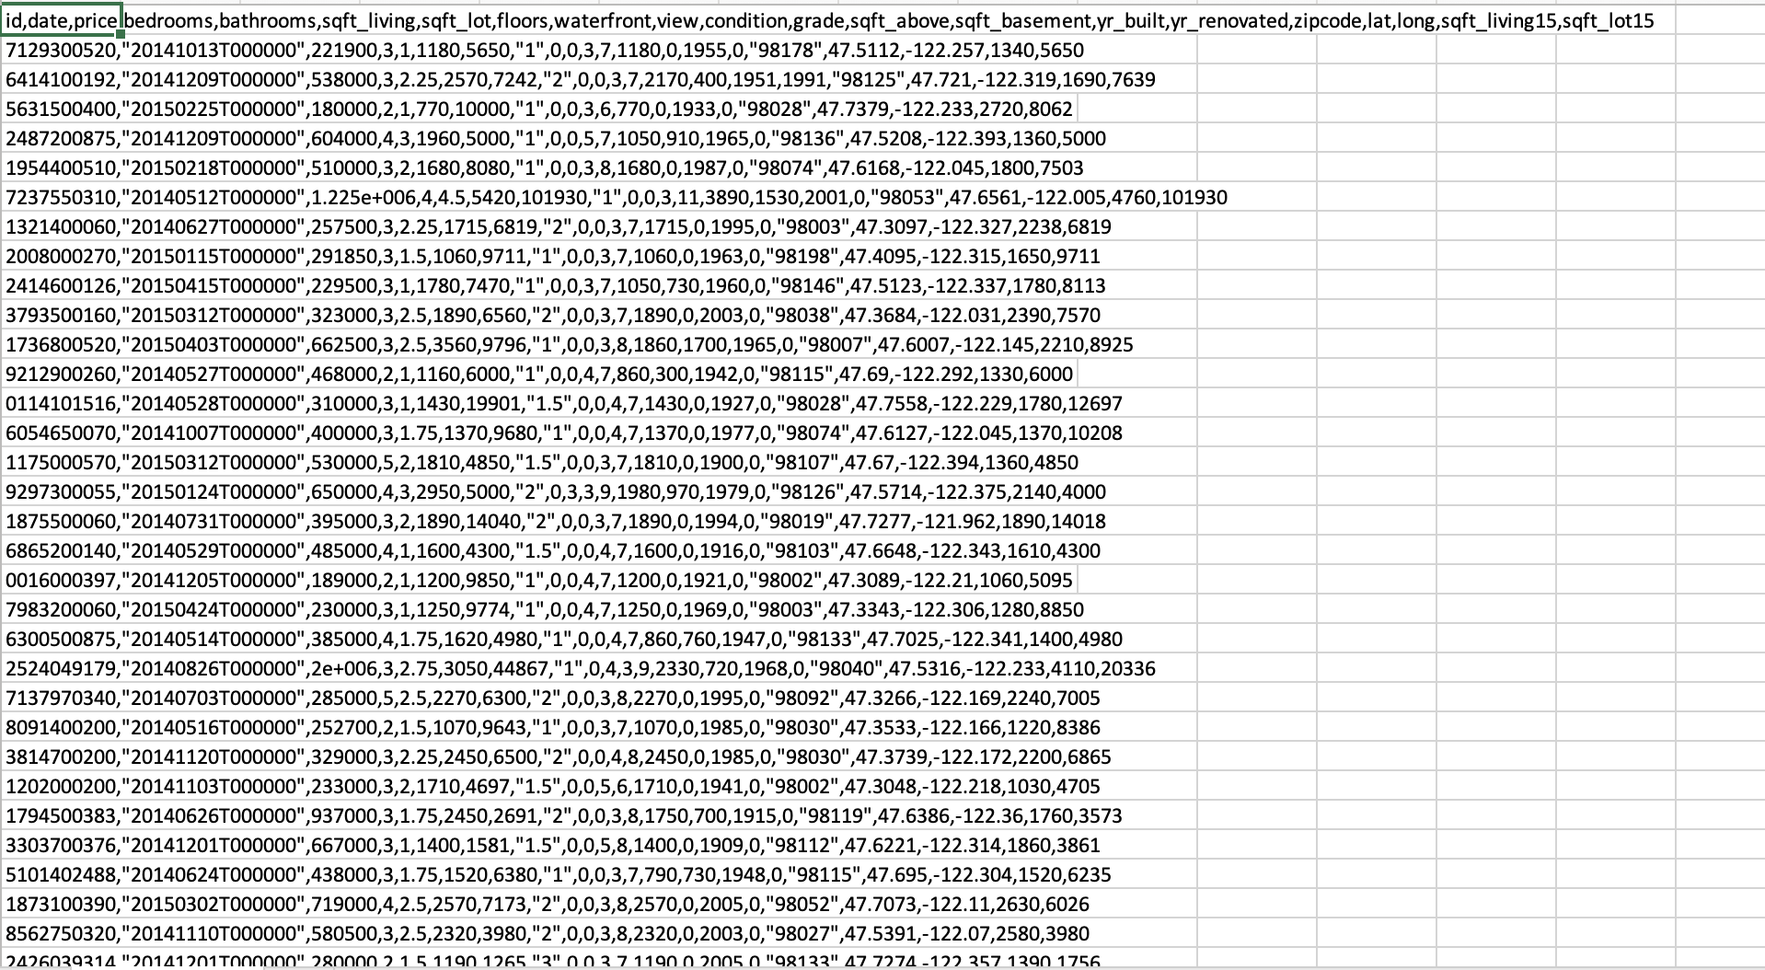

Figure 2 Dataset (csv file)

**Step 2 : Import the dataset to Tableau**

E-commerce website will have many functions such as registration, login and online payment. Along with many user roles such as: Contributor (Seller), buyer, manager, admin, etc. Some functions for users such as displaying products with the most engagement and automatically alerting collaborators to products with low or bad engagement.

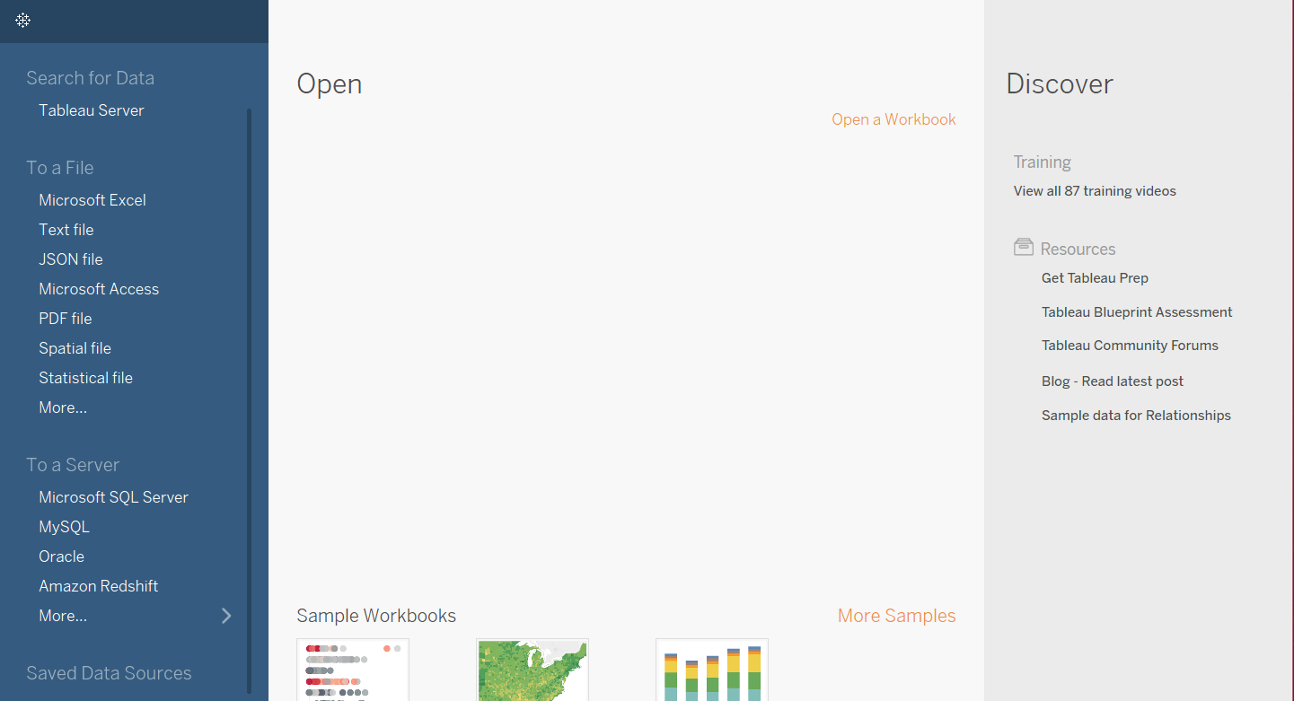

Figure 3 First UI of Tableau

There are 3 main parts in the interface of Tableau based on Figure, part 1 is Connect about uploading data from existing files. With tableau, the application supports uploading data from many sources such as: Excel, Text, Json, etc. Part 2 is the main interface of Tableau; the product and data information will appear here as well as the charts of my project. Part 3 is Discover, which shows tutorials for building a data analytics product and how and where to source externally. If you create a new Workbook from Tableau the UI will be:

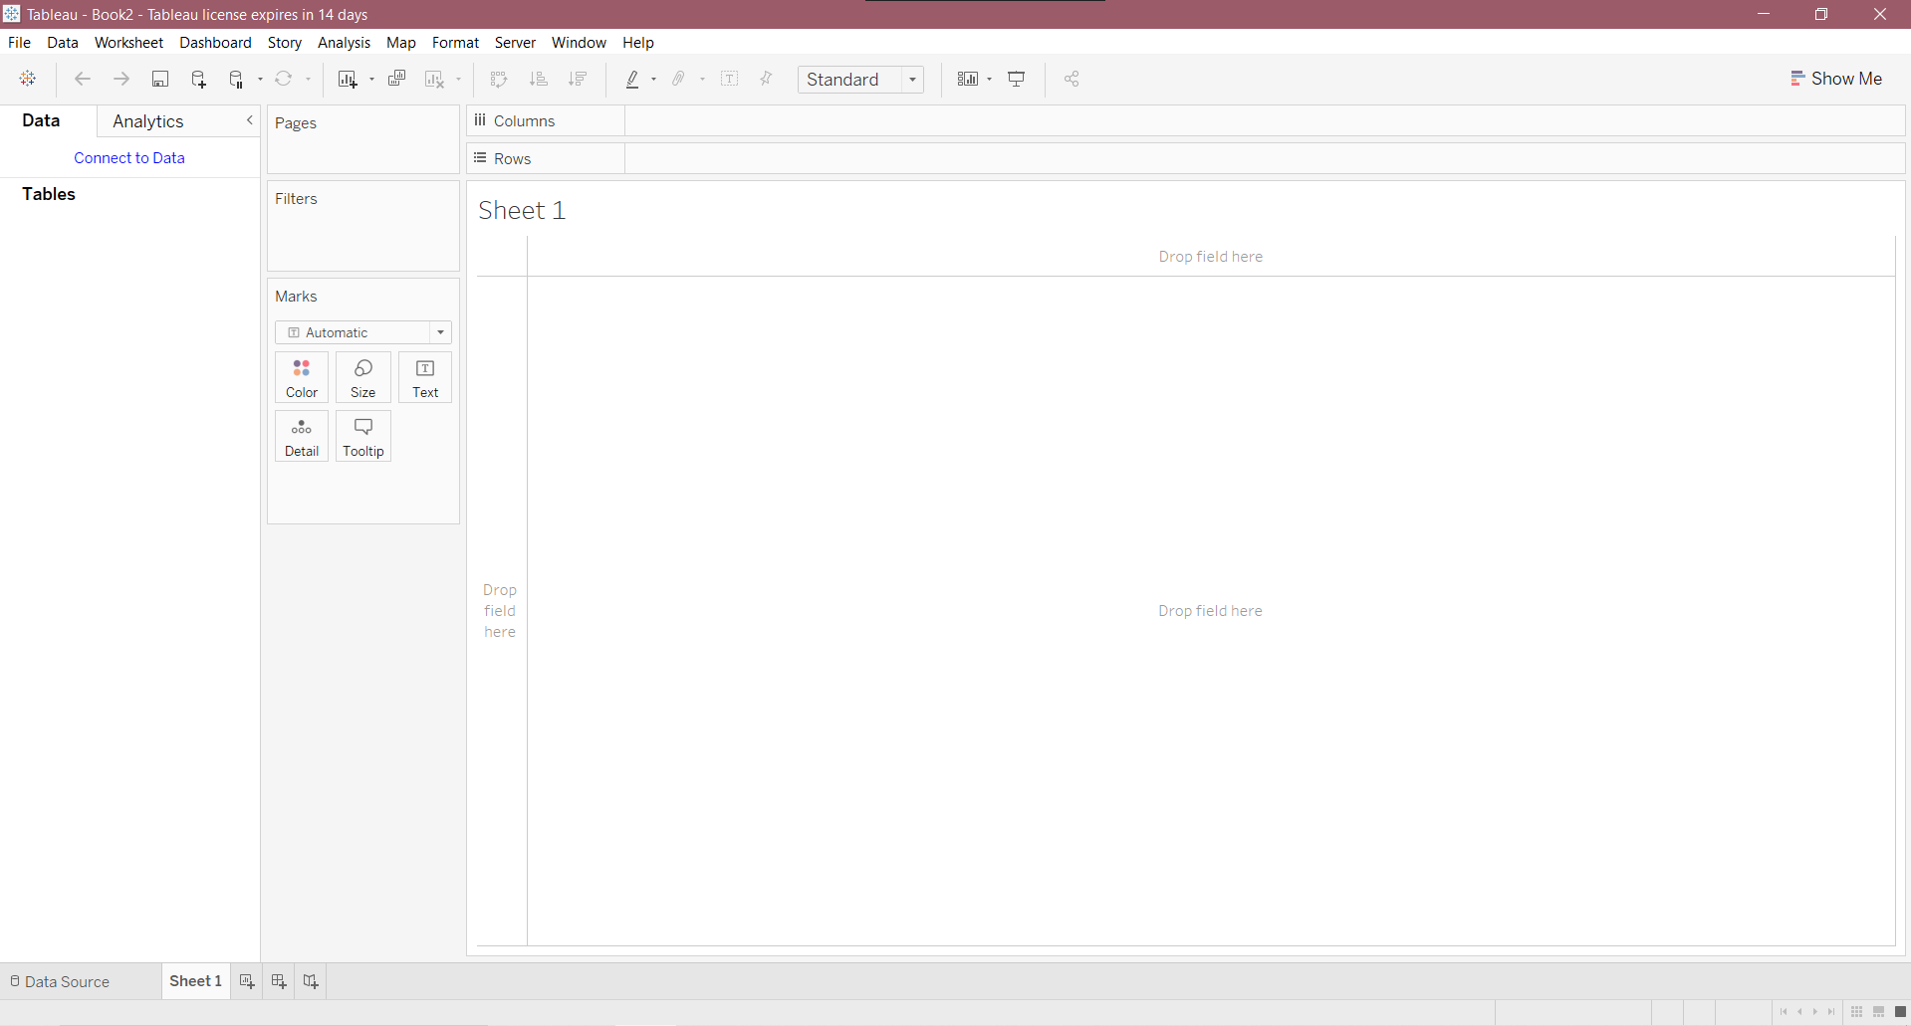

Figure 4 Main UI of Tableau

**Step 3: Make the graph ( line, table, etc.) to analyse the dataset and give summary for this project**

For example to see the price of all houses and the features in that house we can use the table graph for easily to see. With data from Excel, user can open Tableau, and click on Microsoft Excel in To a file in the display.

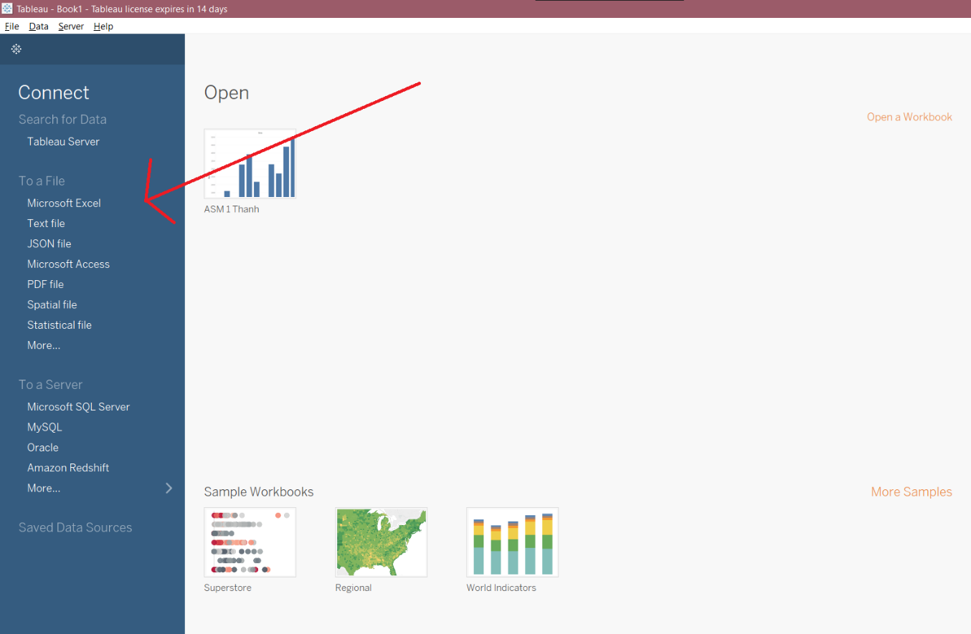

Figure 5 Choosing import file way

In my case, the dataset have been stored In csv file so I imported it by TXT file, then choose the fille of data which u want to import to dataset. The data will be imported to the dataset from the csv file and display on screen.

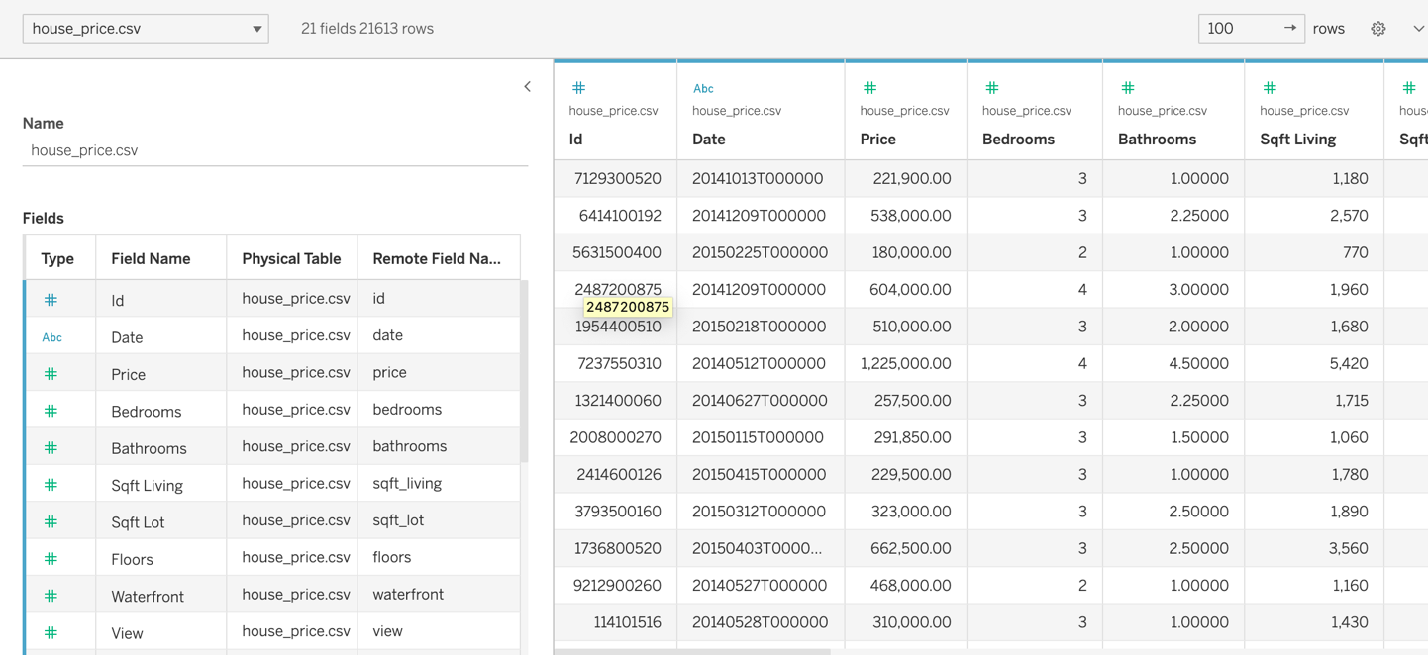

Figure 6 Dataset after import

Firstly, after import dataset to Tableau, I create a new workbook and choose the table graph to make a new data graph for analysing. With 6 data fields are Bathrooms, Bedrooms, Views, Floor, Waterfront and Price.

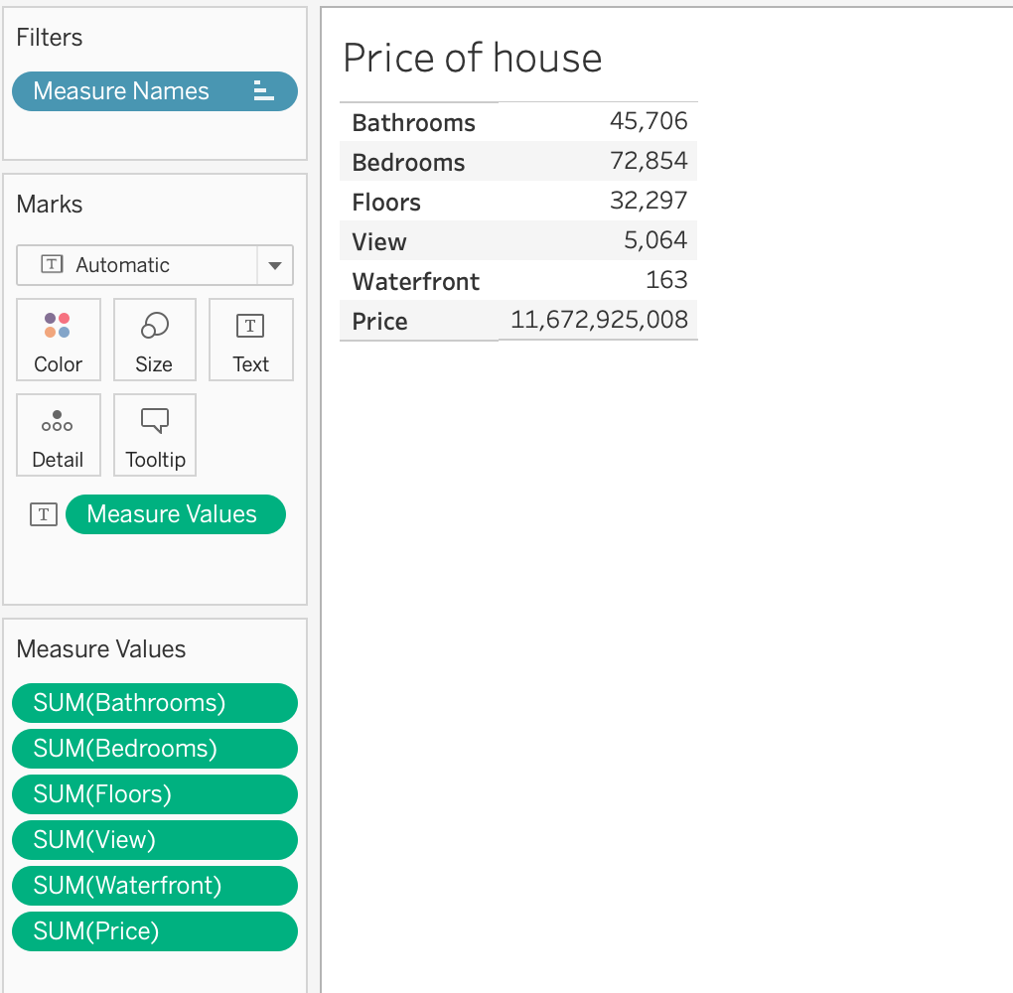

Figure 7 Table of Price of house

From this table, we can see the summary price of all of our houses through the Price row and the features with make that Price. With that data we can also calculate the average price of each one by using the divide.

Another one, to see the price of house depend on date is it increase or decrease, this line graph is also really helpful.

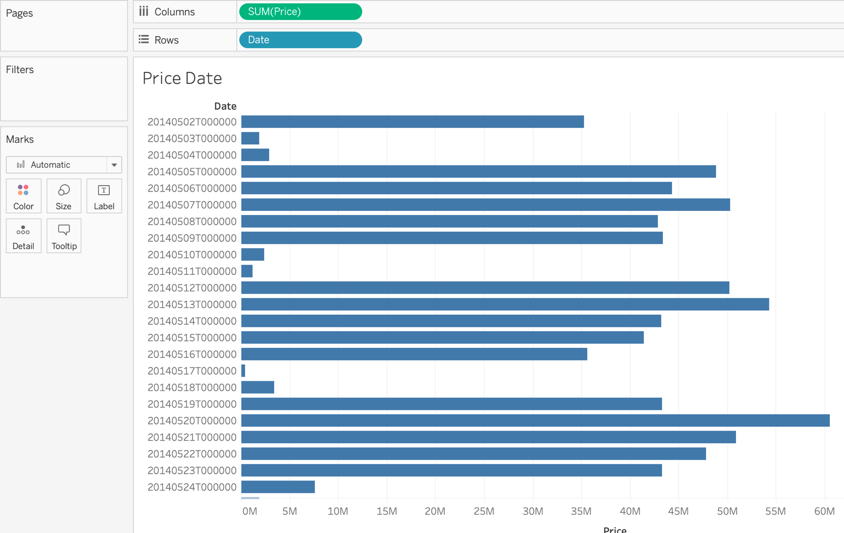

Figure 8 Column of Price and Date

This one help us know that price of our project depends on month of each year. In this line graph, we can see the highest price of our house is in 21/5/2014, which is approximately 60 millions and the lowest is just about 500 thousands.

Next one, to see the total bedrooms and bathrooms had been built depends on year, I decided to use dual lines so see 2 lines of each above on graph for easily to analyse.

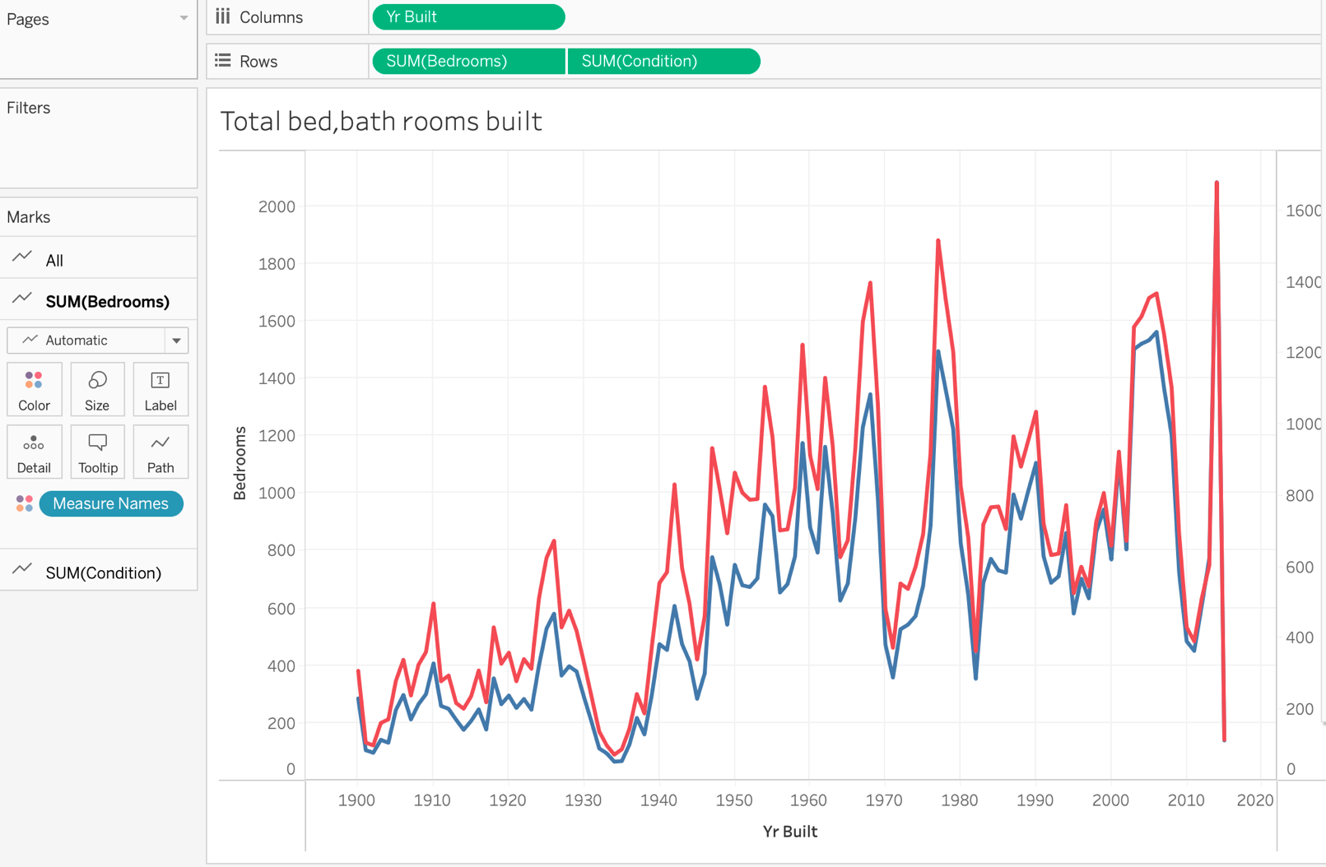

Figure 9 Dual lines graph of Bedrooms and Bathrooms built

Also we can use map with 2 fields Zipcode and Bathrooms, to see the country or area which is a strong market to sell house all around the world. Depend on Zipcode, maps will appear the area and the circle to see directly amount of bathrooms in house have been sold.

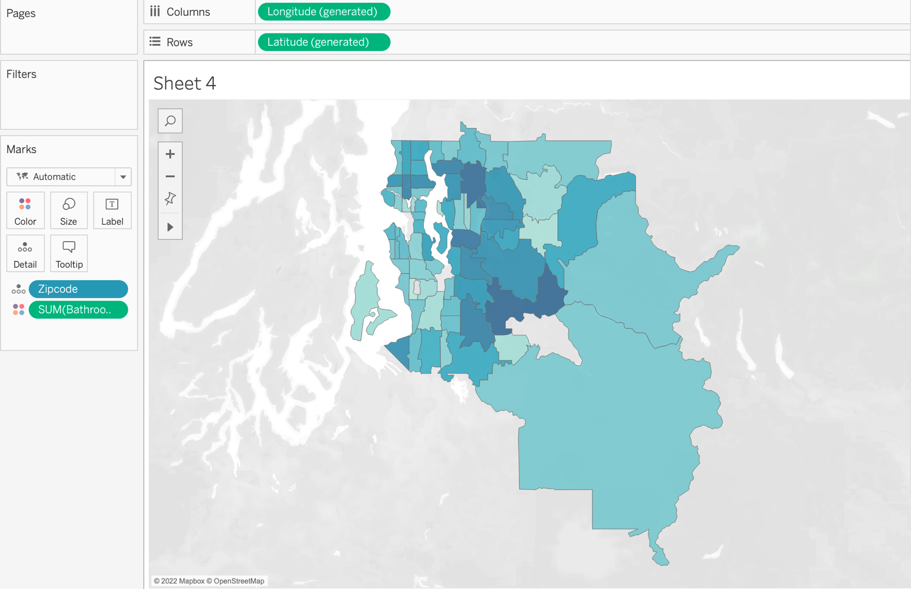

Figure 10 Maps of Zipcode and Bathrooms sold

Business intelligence dashboards enable organizations to make complex data easily understandable and approachable for non-technical users. IT may create content as a starting point, business users can create and view their own dashboards. Self-service BI empowers non-technical users to interact with data. Chipotle used dashboards to create a unified view of their restaurant locations and streamlined their analytical processes. Dashboard-driven data visualizations can help business users identify trends. They can alert to positive trends, isolate negative trends, and offer predictive insights. When Charles Schwab made it possible for thousands of bank branches to create their own dashboards to track performance, they were able to track customer satisfaction with their products without analyzing pages of spreadsheets.

* 1. **Dashboard (Purpose of dashboard)**

The image above illustrates the design of the proposed BI Tool that Courts would use to analyse the Price and Date of there assets in every year. This would be used to aid with better understanding how House are being carried out as compared to how much money are being made in their House selling.

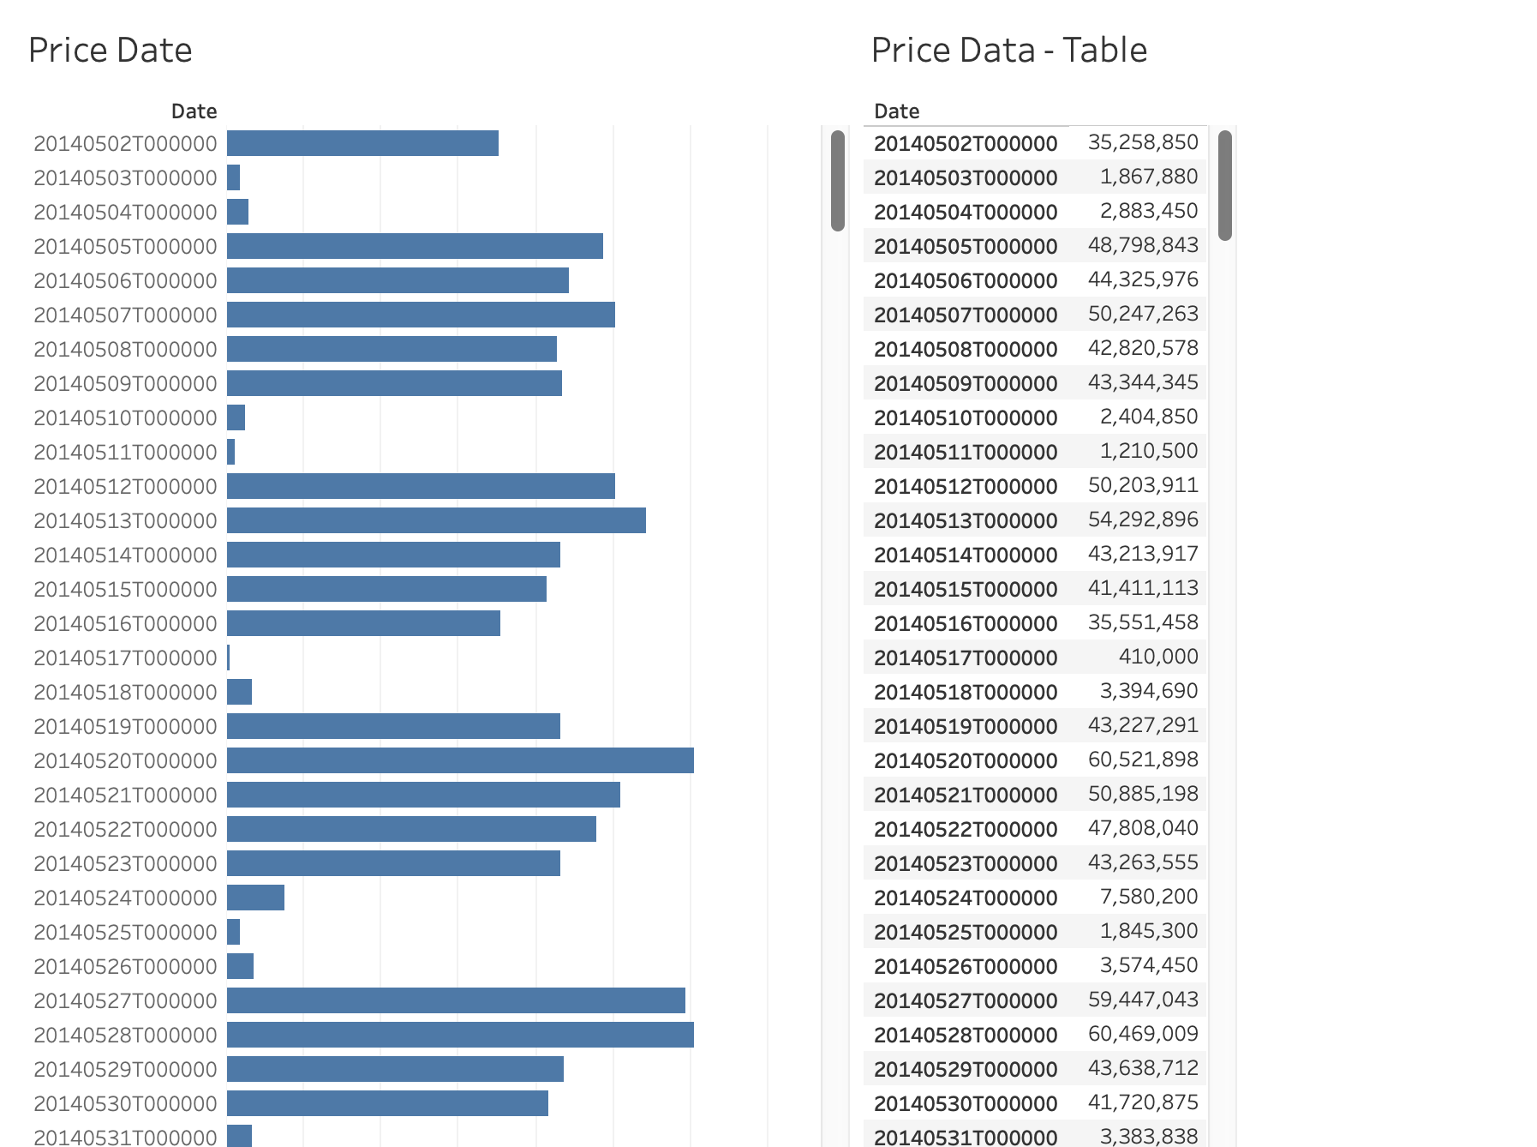

Figure 11 Compare Column and Table graph

* 1. **Each dashboard contain charts (Purpose of chart)**

Price of house – Table : To see the total of rooms/ features and the total price of them.

Maps / bathrooms – Maps: Know the area which is a strongly market to sold house because of the sold before

Total bed/bath rooms built – Dual lines: This one make 2 lines for easily manage about which is the more important room that people care of.

Price Data – column graph: See the price of house in each year and know the income of selling house in every year.

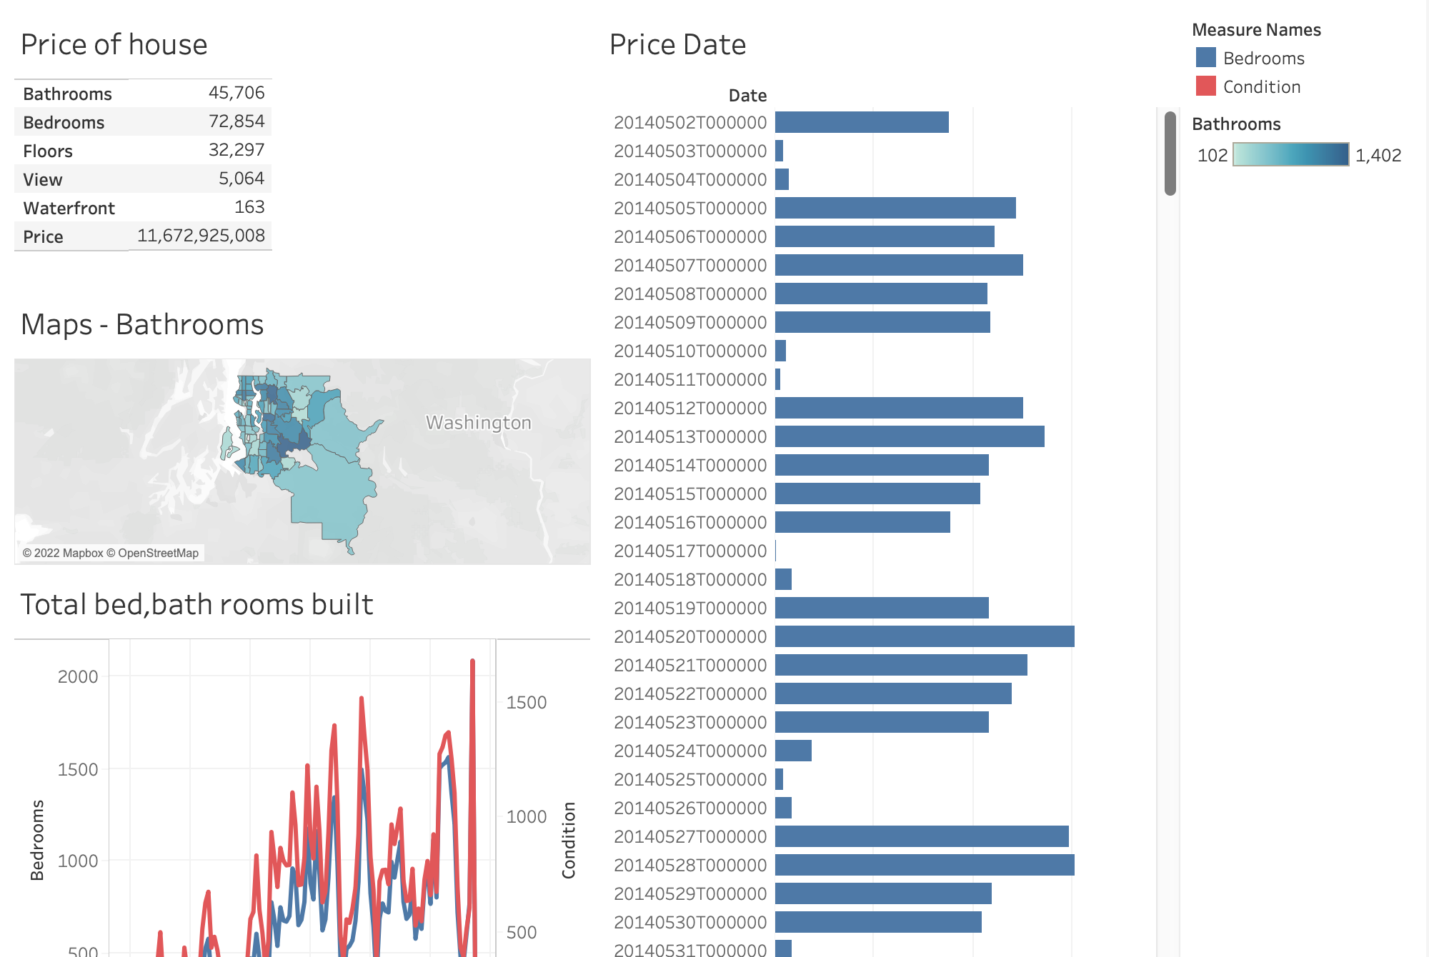

Figure 12 Dashboard

* 1. **Interaction on dashboards (Result / Conclusion / Suggestion)**

The images above were taken to show how the slicer and period were used with specific filters to provide data with a variety of dates, times, and branches.

The Dash Boards for the Business Intelligence Tool are depicted in the images above. This tool includes the four analyses described previously: Sales vs Cost, Most Purchased House's rooms, Number of Rooms, and House price of each year. These assessments will now be merged to create a single business intelligence tool that will assist courts by visually illustrating numerous parameters that are important to them.

This tool would also have two filters for Transaction Date and Branch, in addition to a variety of analysis. These filters would allow users to choose specific criteria on the tool and receive an output that reflected their selections. As an example, take a look at the image below.

The standards that was followed for the design of this tool was based from Gestalt Principles of Designs. Some of the standards that were followed are Similarity, Proximity and Common Fate.

* **Similarity Principle** – This deals with certain elements that is categorised in to groups that have similar qualities. Due to human nature it was natural instinct that we would group elements that are visually alike. Based on the dashboard above, it shows to similarities with all 4 graphs. Two graphs on the left-hand side are strictly vertical blue lines where the two graphs on the right-hand side is blue with orange. majority of the charts.
* **Proximity Principle** – This deals with items that are placed closely together which would appear to have a lot more relatable information than when they are spaced apart. Due to proximity, these graphs have been placed together to allow users to recognise it as one main entity. Based on the design of the dash board it illustrates how all the analyses have been arranged and sorted. It shows that all the filters are located in one general area which is at the top right-hand corner, whereas the other area has the respected graphs that would be affected by these same filters.
* **Common Fate** – This deal with elements that are moving together which would be viewed as a single grouped entity once they are moving together. Based on the design on the dash board, it was specifically designed in this manner to place all graphs together to work in one, however four of these graphs were placed together to give a better understanding of what is transpiring throughout Courts.

# P5 Discuss how business intelligence tools can contribute to effective decision-making.

1. **The important of BI to the business**

The main reasons to invest in a solid BI strategy and system are:

* **Gain New Customer Insights**: One of the primary reasons companies are investing their time, money, and efforts into Business Intelligence is because it gives them a greater ability to observe and analyse current customer buying trends. Once you utilize BI to understand what your consumers are buying and the buying motive, you can use this information to create products and product improvements to meet their expectations and needs and, as a result, improve your organization’s bottom-line.
* **Improved Visibility**: Business Intelligent organizations have better control over their processes and standard operating procedures, as the visibility of these functions is improved by a BI system. The days of skimming through hundreds of pages of annual reports to assess performance are long gone. Business Intelligence illuminates all areas of your organization helps you to readily identify areas for improvement and allow you to be prepared instead of reactive.
* **Actionable Information**: An effective Business Intelligence system serves as a means to identify key organizational patterns and trends. A BI system also allows you to understand the implications of various organizational processes and changes, allowing you to make informed decisions and act accordingly.
* **Efficiency Improvements**: BI Systems help improve organizational efficiency which consequently increases productivity and can potentially increase revenue. Business Intelligence systems allow businesses to share vital information across departments with ease, saving time on reporting, data extraction, and data interpretation. Making the sharing of information easier and more efficient permits organizations to eliminate redundant roles and duties, allowing the employees to focus on their work instead of focusing on processing data.
* **Sales Insight**: Sales and marketing teams alike want to keep track of their customers, and most utilize Customer Relationship Management (CRM) application to do so. CRMs are designed to handle all interactions with customers. Because they house all customer communications and interactions, there is a wealth of data and information that can be interpreted and used to strategic initiatives. BI systems help organizations with everything from identifying new customers, tracking and retaining existing ones, and providing post-sale services.
* **Real-Time Data**: When executives and decision-makers have to wait for reports to be compiled by various departments, the data is prone to human error and is at risk of being outdate before it’s even submitted for review. BI systems provide users with access to data in real-time through various means including spread sheets, visual dashboards, and scheduled emails. Large amounts can be assimilated, interpreted, and distributed quickly and accurately when leveraging Business Intelligence tools.
* **Competitive Advantage**: In addition to all of these great benefits, Business Intelligence can help you gain insight into what your competitors are doing, allowing your organization to make educated decisions and plan for future endeavours.

# P6 Explore the legal issues involved in the secure exploitation of business intelligence tools

1. **Data kind which is collected**

* Certain types of data collected are subject to legal requirements.
* The HIPAA privacy regulations provide federal protections for personal health records and are strictly enforced to protect sensitive information.
* Information that can be used to trace a person's identification, such as a person's name, social security number, or date of birth, is likewise safeguarded.
* When collecting payment information, businesses must also follow specific procedures to protect sensitive financial information.
* Companies must be aware of all data they collect in order to meet the regulatory requirements that each type of data entails, which is crucial.
* These regulatory provisions are in place to protect consumers' interests.
* Customers' personal information can be quite vulnerable.
* The company's image and value will rise, and its reputation will contribute in its growth, if customer knowledge is adequately maintained.

1. **How data stored**

* To secure the data base, the organization is responsible for setting proper security measures.
* Because the consumer information that businesses are obligated by law to gather, often known as business inventory, is critical to the entire organization, hackers will swiftly target this database.
* Businesses must follow necessary regulations and strong security requirements to avoid regulatory threats and preserve personal consumer information.
* To prevent data theft, businesses can keep data on a dedicated company server and engage a capable management staff.
* Allow users with permission to view data and obtain access to it.

1. **How Big Data used**

* A company's efforts to handle a huge number of data are futile without preparation; the amount of data is only useful if the management understands how to apply the approach.
* Businesses will profit from Big Data in a variety of ways: Only a few applications include predicting consumer behaviour, detecting fraud, selecting appropriate marketing targets, and tailoring information. The customers have been contacted.
* However, because of how the data will be used, companies are required to communicate this information to customers as a condition of data processing. Furthermore, Big Data follows strict criteria that, in some circumstances, need meticulous planning.
* For instance, if a phone marketer collects information about a customer's phone number and home location then resells it to carriers that sell sim cards or phone equipment in order to get usage data, this is a violation of the law, and the information is not being handled appropriately.
* Another example: being an employee of company A and selling company data to company B while the two companies are competing is illegal.
* Inquiring about data formats as well as how to exploit and use data content is one technique to decrease regulatory risks and produce a successful Big Data solution.
* If Big Data can be obtained and used properly, it may become a huge asset for businesses and help them make better business decisions.

# REFERENCES

Jake, F (2021) Business Intelligence (BI) [online] Available at: <https://www.investopedia.com/terms/b/business-intelligence-bi.asp>

Tableau () Real-World Applications of Business Intelligence (BI) [online] Available at: <https://www.tableau.com/learn/articles/business-intelligence-examples>

Jayanthi, R (2009) BUSINESS INTELLIGENCE: CONCEPTS, COMPONENTS, TECHNIQUES AND BENEFITS. Pg. 61-62

Jayanthi, R (2009) BUSINESS INTELLIGENCE: CONCEPTS, COMPONENTS, TECHNIQUES AND BENEFITS. Pg. 68-69

Omnisci () Business Intelligence [online] Available at: <https://www.omnisci.com/technical-glossary/business-intelligence>

Elitsa, K (2020) How to Create a Matplotlib Bar Chart in Python? [online] Available at: <https://365datascience.com/tutorials/python-tutorials/bar-chart-python-matplotlib/>

Analytics (2019) Why Business Intelligence Is Important [online] Available at: <https://analytiks.co/why-business-intelligence-is-important/>